Part 1:

#include "library.h"

void main()
{ print("Greetings, Human!");
new_line();
print("2 plus 3 is ");
print(2+3);
new_line(); }

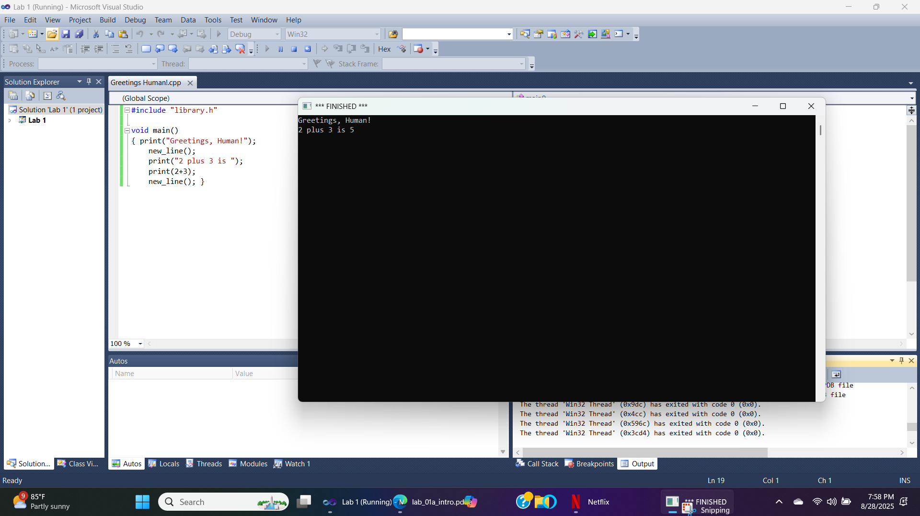

Part 2: Pentagon

#include "library.h"

void main ()
{ make_window(400, 400);
set_pen_color(color::dark_green);
set_pen_width(5);
move_to(150, 250);
draw_distance(100);
turn_right_by_degrees(72);
draw_distance(100);
turn_right_by_degrees(72);
draw_distance(100);
turn_right_by_degrees(72);
draw_distance(100);
turn_right_by_degrees(72);
draw_distance(100);
set_pen_color(color::orange);
set_font_size(24);
write_string("Pentagon"); }

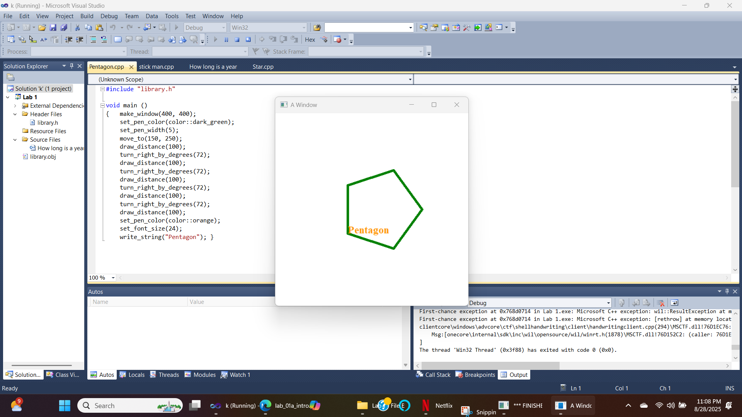

- How long is a year?

#include "library.h"

void main()
{
make_window(400,400);
int seconds_per_minute = 60;
int minutes_per_hour = 60;
int hours_per_day = 24;
int days_per_year = 365;

int seconds_in_year = seconds_per_minute * minutes_per_hour * hours_per_day * days_per_year;

cout <<"A year is " <<seconds_in_year << " seconds long" << endl;
write_string("Number of seconds in a year");
}

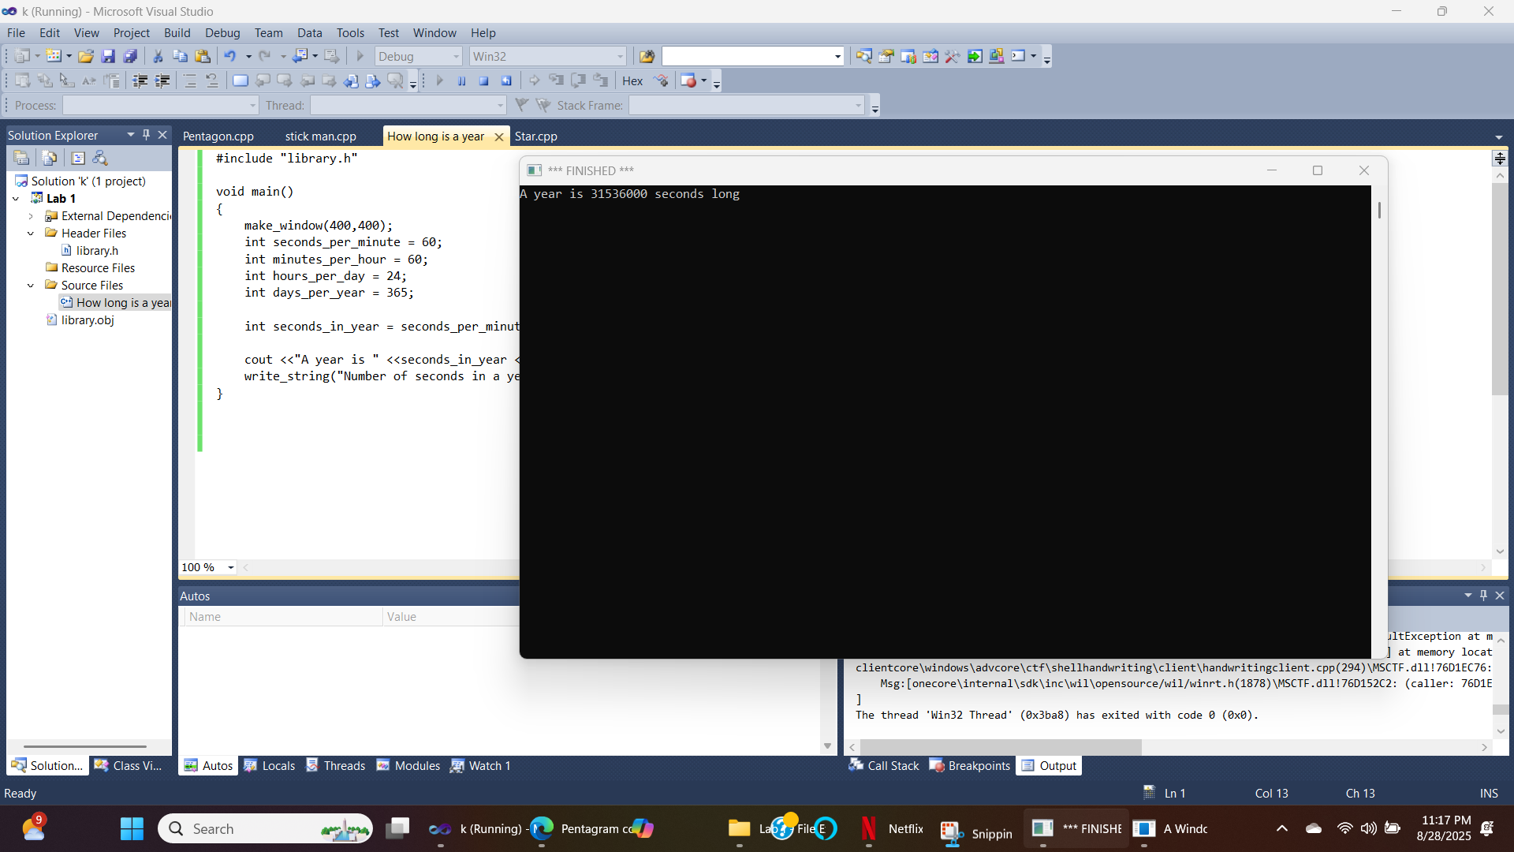

- Black Magic, stars

#include "library.h"

void main()
{
make_window(400,400);
set_pen_color(color::dark_green);
set_pen_width(5);
move_to(200,200);
draw_distance(200);
turn_right_by_degrees(144);
new_line();
draw_distance(200);
turn_right_by_degrees(144);
new_line();
draw_distance(200);
turn_right_by_degrees(144);
new_line();
draw_distance(200);
turn_right_by_degrees(144);
new_line();
draw_distance(200);
turn_right_by_degrees(144);
set_pen_color(color::orange);
set_font_size(24);
write_string("star");
}

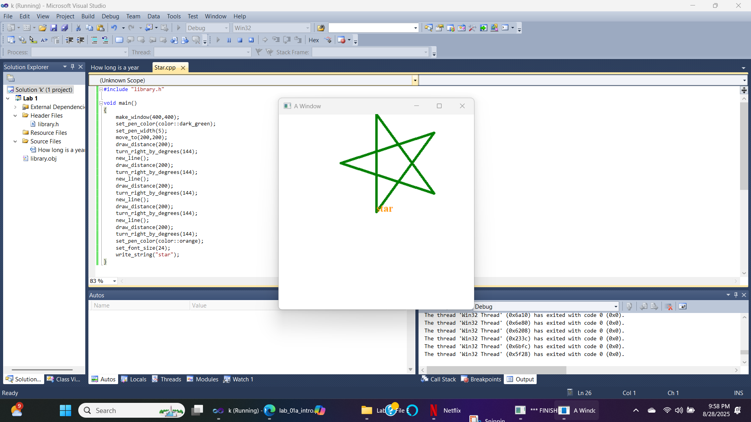
- Stick men, round heads
#include "library.h"

void main()
{
make_window(400,400);
set_pen_color(color::purple);
set_pen_width(5);
move_to(180, 100);
draw_distance(40);
turn_right_by_degrees(90);
draw_distance(40);
turn_right_by_degrees(90);
draw_distance(40);
turn_right_by_degrees(90);
draw_distance(40);
turn_right_by_degrees(90);
move_to(200,200);
new_line();
draw_distance(100);
move_to(200,130);
new_line();
turn_right_by_degrees(120);
draw_distance(50);
move_to(185,140);
new_line();
turn_left_by_degrees(60);
draw_distance(20);
move_to(185,140);
new_line();
turn_left_by_degrees(100);
draw_distance(30);
move_to(200,200);
new_line();
turn_left_by_degrees(100);
draw_distance(50);
move_to(245,225);
new_line();
turn_right_by_degrees(80);
draw_distance(50);
set_pen_color(color::green);
set_font_size(24);
move_to(100,300);
write_string("stick man with left arm raised");
}
